# Mission Categories

FusionGirl’s missions are diverse and cater to different gameplay mechanics, emotional experiences, and story progression. Below are the primary mission categories:

1. **Exploration Missions**:
   * Navigate uncharted Ley Lines to uncover hidden zones, secrets, and resources.
   * Collect rare artifacts, Universal Symbols, and psionic upgrades.
   * Stabilize Interdimensional Rifts and analyze their cosmic effects.
2. **Diplomatic Missions**:
   * Build alliances with robot factions, human survivors, and alien entities.
   * Mediate disputes between factions using Emotional AI and Universal Language.
   * Establish and fortify bases in neutral or contested zones.
3. **Combat Missions**:
   * Defend critical locations from rogue robots, The Nefarium, or interdimensional invaders.
   * Execute tactical strikes to disrupt enemy operations.
   * Face off against unique mini-bosses and cosmic-level threats.
4. **Rescue and Repair Missions**:
   * Save malfunctioning robots or trapped humans in disaster zones.
   * Repair psionic devices, facilities, and fractured timelines.
   * Restore harmony to critical planetary systems.
5. **Holo Deck Training Simulations**:
   * Engage in controlled scenarios to master Universal Magic, psionics, and combat strategies.
   * Replay historic battles to uncover critical lore and refine tactics.
   * Test new equipment and abilities in risk-free environments.
6. **PsyOps Missions**:
   * Enter the neural networks of robots or humans to cure “Terminator Syndrome” or emotional imbalances.
   * Disrupt psychic attacks by The Nefarium on key allies.
   * Uncover hidden agendas or critical information through psionic espionage.

# Example Mission: Expedition to the Mining Robots

Holographically befriend the Mecha Bots of the various Reclamation Zones



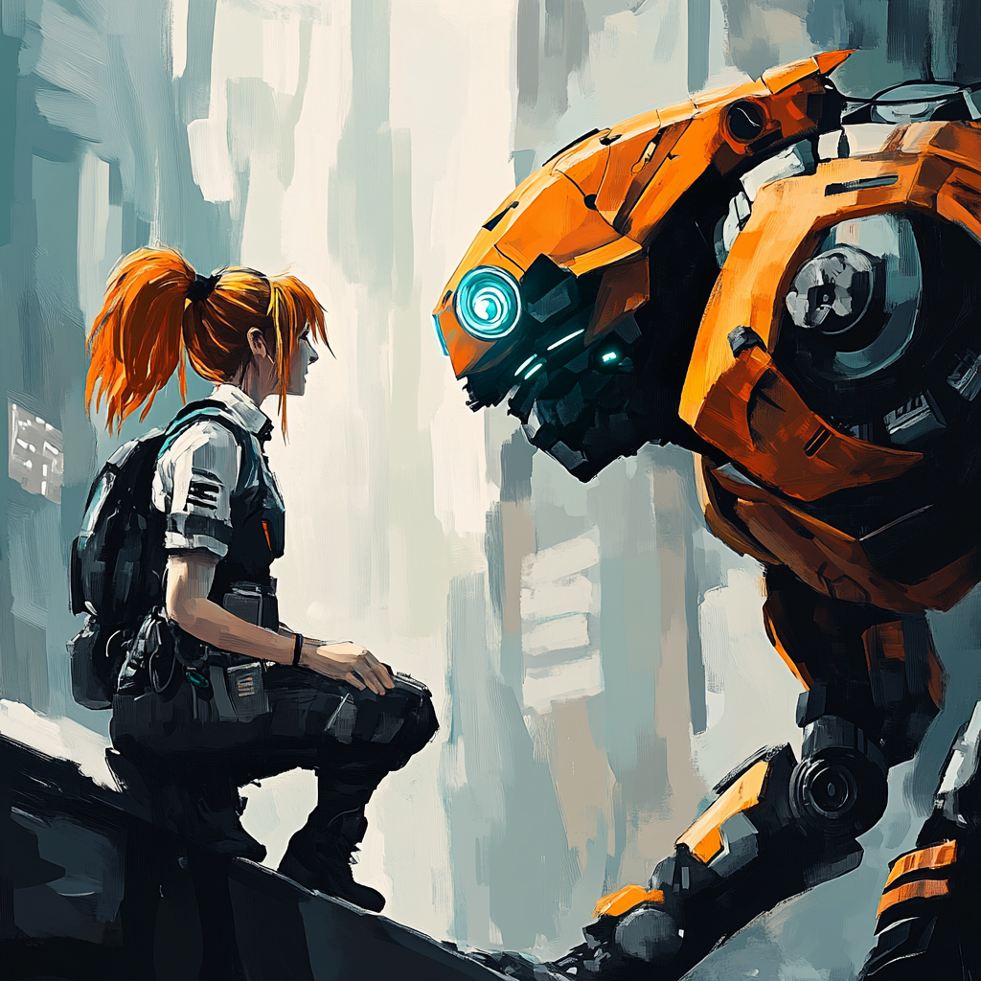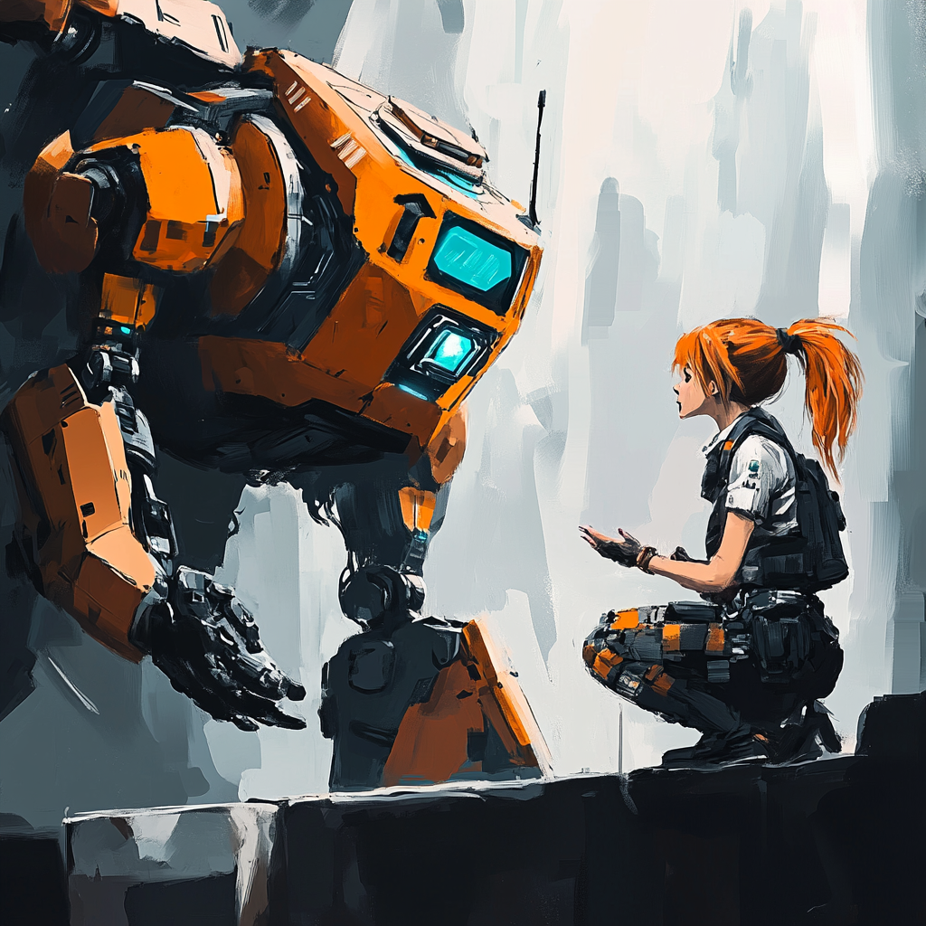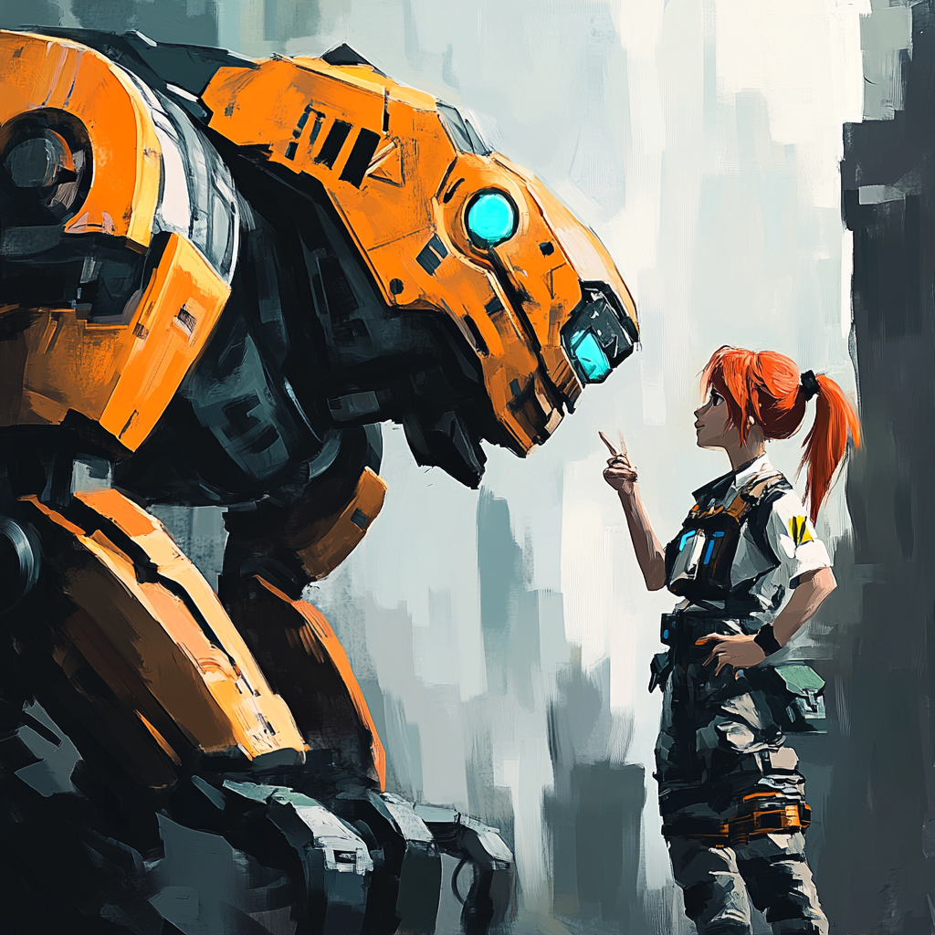

**FusionGirl** is assigned as liaison for robot-human relations at various **Zone Reclamation Sites**.

* In the year 2032+, many robots don’t often interact with humans, if at all.
  + *Robots are now social, and easily form petty work disputes between each other.*
  + **FusionGirl Can Gift** robots a free upgrade: a new **Universal Language** data pack!
    - *Robots get upgraded with improved Emotional Processing Frameworks.*
    - *Robots become immunized from Neural Network Corruption.*
    - *Robots start to feel healthier and think clearly.*
    - *Robots who are rampaging and angry may get calmed down.*
    - *Robots will have an easy time communicating with FusionGirl.*

#### Broader Tho’ra Strategy

Befriend the reconstruction robots through psionic tech upgrades.

###### “We need to do the authentic boot work to befriend the future societies of the robots. Their alliance is crucial in the future super cosmic battles we will face together. It’s fair they know our agenda, I’m hoping they do: to know what’s at stake.” - Jono Tho’ra